Harley Chapter 5 “Deconstructing the Map”

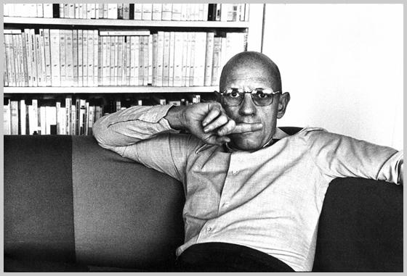
Michel Foucault (foo-coe) – maps conceal power and knowledge


Jacques Derrida (dare-a-dah) maps are rhetorical

Deconstruction depends on the concept of construction. Maps are constructions, therefore they can be deconstructed (151).

“Deconstruction urges us to read between the lines of the map—‘in the margins of the text’—and through its tropes to discover the silences and contradictions that challenge the apparent honesty of the image” (153).

“’To deconstruct,’ it is argued, ‘is to reinscribe and resituate meanings, events and objects within broader movements and structures; it is, so to speak, to reverse the imposing tapestry in order to expose in all its unglamorously disheveled tangle the threads constituting the well-heeled image it presents to the world’” (159).

“Maps are slippery customers” (160). They are enigmas, puzzles, or as Dr. Rupp called them “lies.”

Cartographic “rules” based on a scientific epistemology—
“The object of mapping is to produce a ‘correct’ relational model of the terrain. Its assumptions are that the objects in the world to be mapped are real and objective, and that they enjoy an existence independent of the cartographer; that their reality can be expressed in mathematical terms; that systematic observation and measurement offer the only route to cartographic truth; and that this truth can be independently verified” (154).

A “striking” belief in science; the ideas that “by the application of science ever more precise representations of reality can be produced” (154-155).

The Peters projection caused hysteria (155)

Harley believes that there is a second set of rules—those that govern the cultural production of maps (156).

Those cultural rules include “values, such as those of ethnicity, politics, religion, or social class, and they are also embedded in the map-producing society at large. Cartographic discourse operates a double silence toward this aspect of the possibilities for map knowledge. In the map itself, social structures are often disguised beneath an abstract, instrumental space, or incarcerated in the coordinates of computer mapping” (156).

1. Rule of ethnocentricity—societies place their own territory at the center of the map (156).
2. Rule of hierarchy—“distinctions of class and power are engineered, reified, and legitimated in the map by means of cartography signs” (158).

Harley claims that these rules go beyond the scientific discourses of classification and measurement. Power is thus hidden and at the same time legitimated (158).

“Maps are a cultural text” (159).

Maps have, according to Harley, a “narrative quality.” How so?

Pages 160-161 provide a decent deconstruction of a map.

Maps are rhetorical. “There is nothing revolutionary in the idea that cartography is an art of persuasive communication” (163).

“All maps strive to frame their message in the context of an audience. All maps state an argument about the world and they are propositional in nature. All maps employ the common devices of rhetoric such as invocations of authority (especially in ‘scientific’ maps) and appeals to a potential readership through the use of colors, decoration, typography, dedications, or written justifications of their method. Rhetoric maybe concealed but it is always present, for there is no description without performance (163).

Maps exercise power. Where do they come from? Who is the map for? According to Harley, the map is a juridical power unit—a map “facilitates surveillance and control” (165).

“Cartographers manufacture power; they create a spatial panopticon. It is a power embedded in the map text” (165).

The cartographic process is powerful. “The way maps are complied; and the categories of information selected; the way they are generalized, a set of rules for the abstraction of the landscape; the way elements in the landscape are formed into hierarchies; and the way various rhetorical styles that also reproduce power are employed to represent the landscape …. The world is disciplined. The world is normalized. We are prisoner in its spatial matrix” (166).

“The map is a silent arbiter of power” (166).

Map of the University District: http://udistrict.wsu.edu

