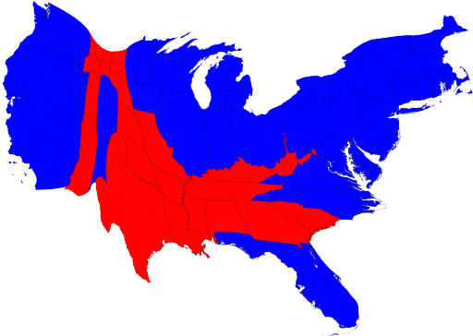

The population cartogram from the 2008 Presidential race.
Source: http://www-personal.umich.edu/~mejn/election/2008/

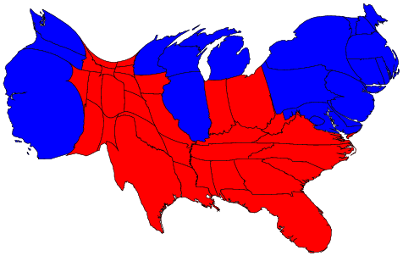

The population cartogram from the 2004 Presidential race.
Source: http://www-personal.umich.edu/~mejn/election/2004/

